Term 4
Dates for your diary…

bekah.parker@aberdeenshire.gov.uk
kinellar.sch@aberdeenshire.gov.uk
01224 472887 (Nursery)
01224 472888 (School)

Newsletter
May 2021

Dear Parents,
Welcome to Kinellar Nursery Term 4 Newsletter. We would like to say a warm welcome to our new starts who have settled into nursery very well and are picking up our nursery routines quickly. As always we will be continuing our ‘free flow’ play letting the children take leadership of their own learning.  Our big focus this term will be supporting children to seamlessly transition towards Primary 1.  Drop off/Pick up  We would like to thank you for your continued support and patience with social distancing and wearing a face covering at drop off/pick up. Just a reminder that there is a one-way system in the playground to follow when dropping your child off in the morning and please ensure you are dropping off your nursery child before children further up the school.  AM drop off – 8am-9am AM pick up -12.45pm-1pm  PM drop off – 1pm-1.15pm PM pick up – 5pm-6pm  Please ensure you stick to these times to avoid disrupting the nursery session. Appointments and authorised changes are an acceptance to the rule.  1140 Hours  As you are aware with the 1140 hours our main priority is to be able to offer you the sessions you require to meet your individual needs as much as possible. Unfortunately this has been unable to happen due to Covid 19 but please be assured that as guidance changes hopefully we will be able to provide these sessions in the near future. At the moment, our model for after the Summer holidays is:  Monday, Tuesday, Wednesday AM & Thursday, Friday PM  OR  Monday, Tuesday, Wednesday Pm & Thursday, Friday Am  Staffing  Mrs Nicol is now off on maternity leave and is doing a wonderful job of Mummy to Ava.  Miss Bekah Parker has stepped in in the interim to cover the position of Early Years Senior Practitioner and is always available to answer any questions you may have. Contact details can be found at the top of this page. | May Holiday (Nursery Closed) – 3rd May 2021  Wellbeing Week – 24th - 28th May 2021  End of Term 4 – 25th June
Wellbeing Week  Wellbeing week is being celebrated across the school to celebrate the children and support emotional health and wellbeing. During this week, the nursery will have the chance to use bouncy castles and other large toys during the week.  Nursery Uniform  You have the option to purchase a sweatshirt or t-shirt in a variety of sizes and colours with the nursery logo embroidered. This is not a requirement to be worn within the setting. Nursery t-shirts and jumpers are available to buy online.  Web: www.ripplesforschools.co.uk  Email: info@ripplesprints.com  Label belongings  Please remember to label your child’s belongings to avoid any confusion!  Interactive Learning Diary (ILD)  Keep a look out for updates of your child’s progress on the ILD. If you have any issues getting signed up, please speak to Miss Burgess.  We would like to continue to encourage parents to post home achievements or comment on your child’s nursery observations. As always, your feedback is very much appreciated.  Facebook  We will continue to use our Facebook page to send out reminders and communicate with families. It has been a useful resource during the recent times, and we would love to support this in continuing.  If you haven’t already, please search for us at Kinellar Nursery and we will be happy to accept you.  Please note this is a private page. |  | Snack Fee’s  Snack fees are now being processed; you will receive notification soon when these are due. Our preferred method of payment is by bank transfer. (Details can be found on the email). Please put your child’s name as Reference.  Nursery Absences  Please inform us if your child will be absent from nursery. We would ask you to use the nursery phone number in order for us to keep better track of attendance etc. 01224 472887.  Before Arrival at Nursery  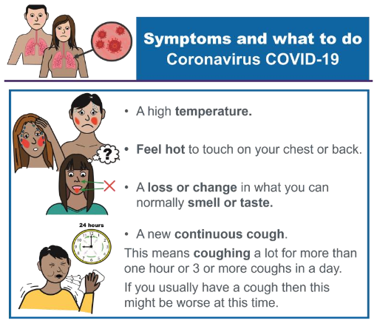  Before leaving your home, please ensure your child is well and that no other members of the household are symptomatic. In line with Government and Local Authority Advice, we have a zero-tolerance approach to any symptoms shown and will use isolation procedures. The ‘Test and Protect’ approach will be used for any person who reports symptoms.  Thank you  Thank you for your continued support and patience at this time. There have been many changes to Nursery and we are still finding our feet with some routines etc. but are enjoying embracing new challenges!

